WORKING DRAFT — NOT FOR USE
Sideline Screen / Duck Blind
Construction and Field Operations Manual
The nominal 4 ft x 8 ft sideline screen provides the color guard with a concealed area for storing equipment and making costume or equipment changes. The frame is constructed from 3/4-in. EMT conduit, off-the-shelf brackets, and 3D-printed parts. Decorative vinyl covers the finished face. The completed screen folds flat for transport and storage and unfolds for field deployment.
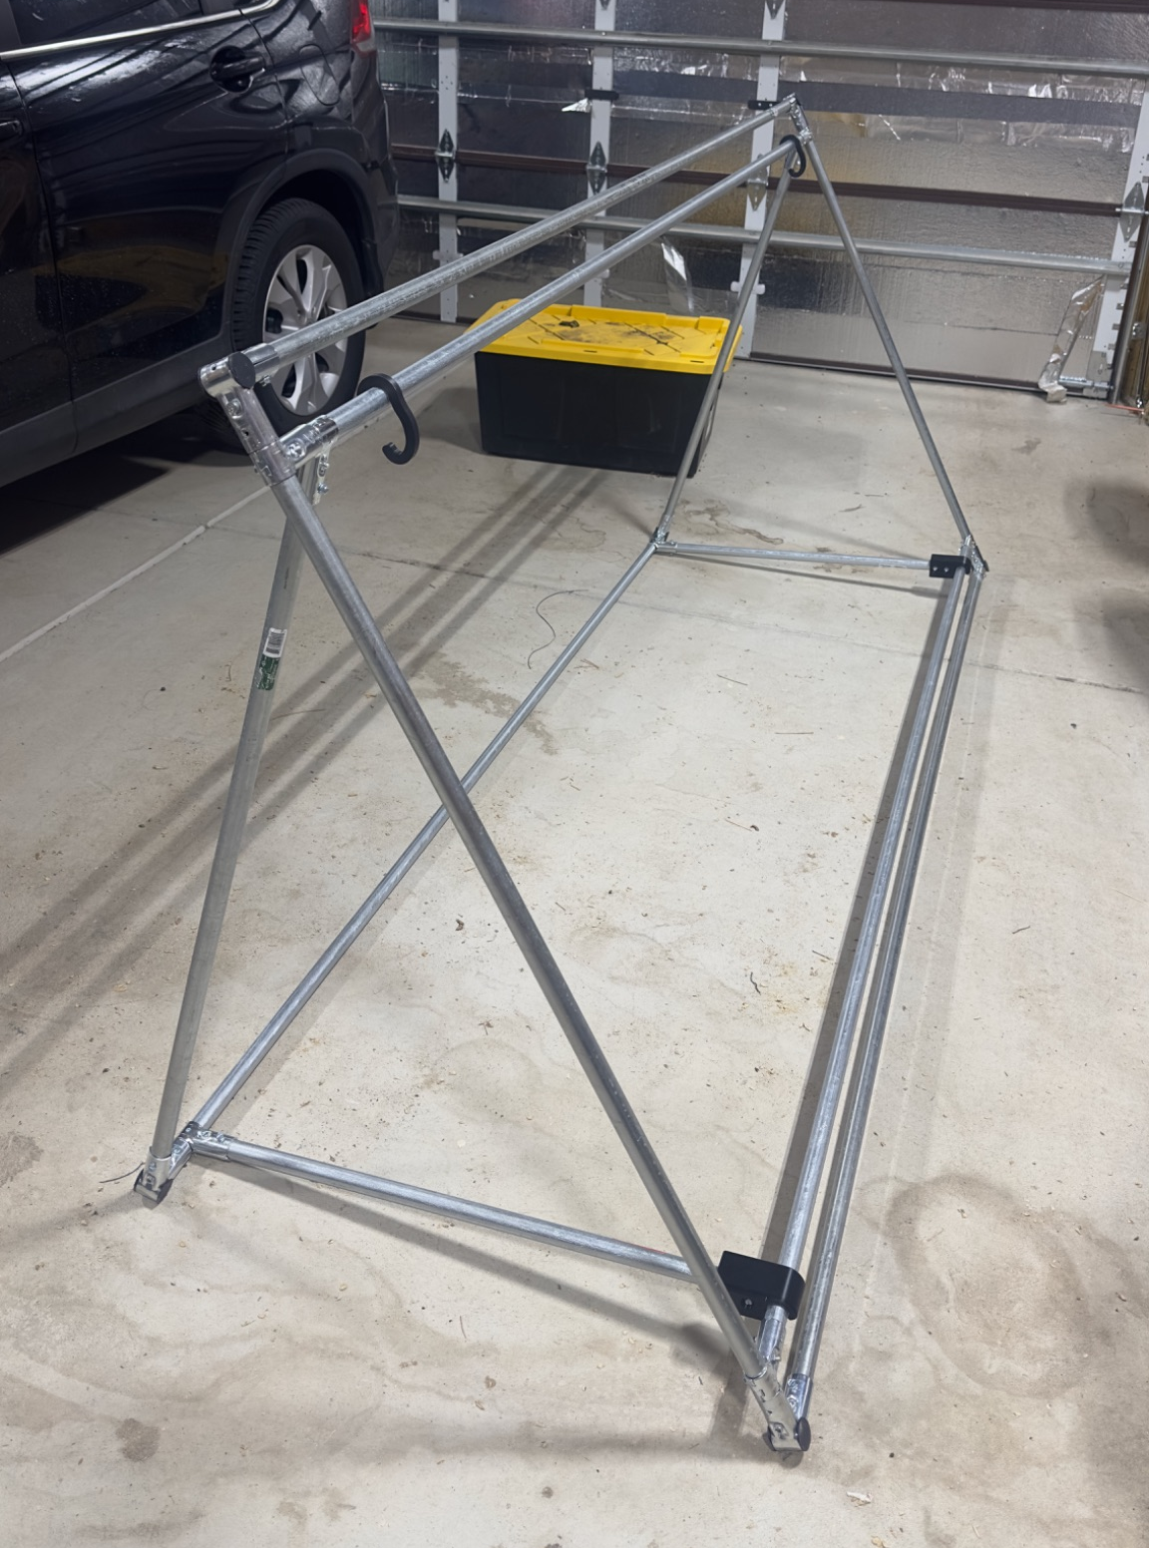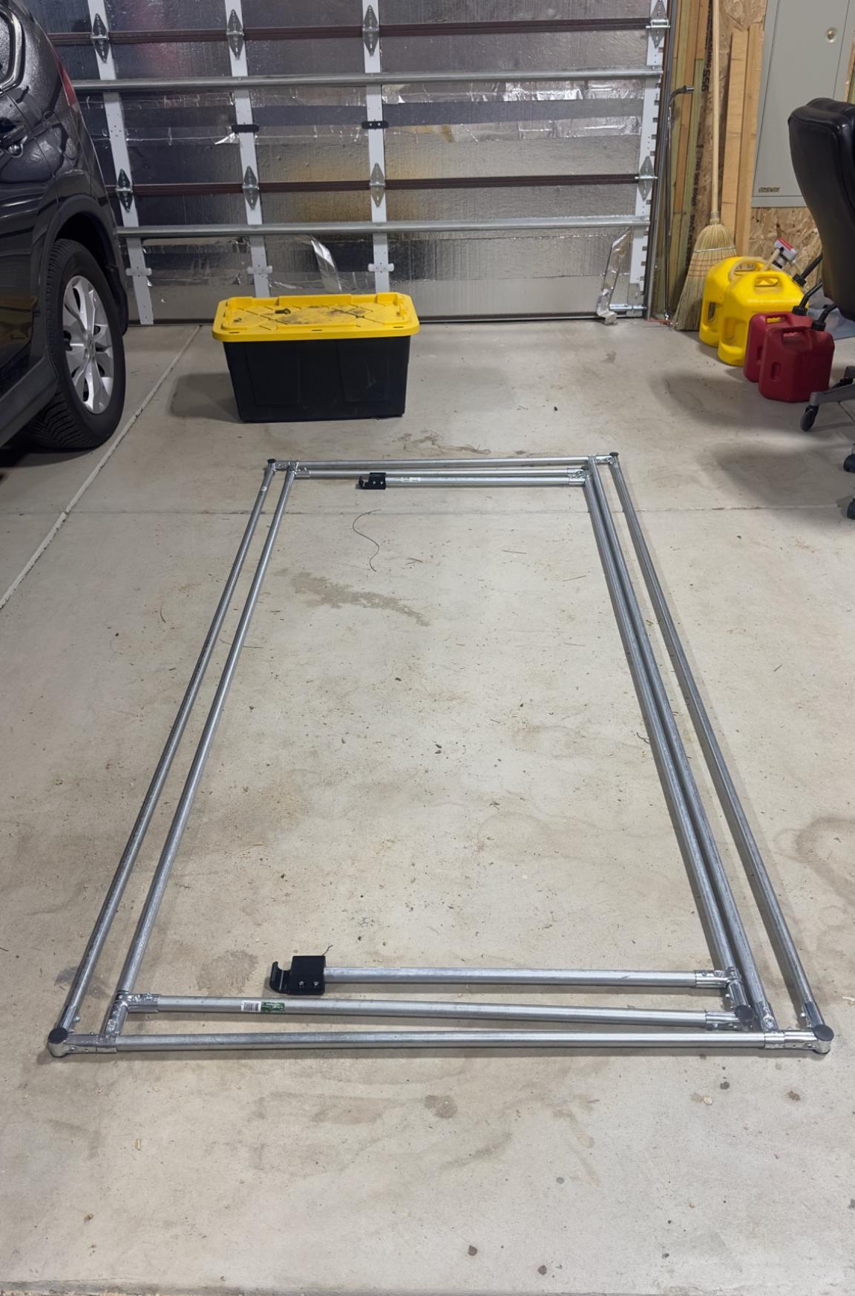
Screen shown deployed and folded for storage.
Release v0 (unreleased) | Development build D29 | September 11, 2026
Version | Date | Status | One-line description
D24 | 2026-09-01 | Working draft | Imported legacy v24 draft as controlled baseline D24
D25 | 2026-09-01 | Working draft | Standardized status markings, footers, and added visible version history table
D26 | 2026-09-01 | Working draft | Standardized document architecture, 2026 CBA rules, transport cart specifications, and canonical cost breakdown tables
D27 | 2026-09-09 | Working draft | Add vinyl installation procedure, dimensions specifications, and tape/clip fastening
D28 | 2026-09-10 | Working draft | Add aerodynamic wind loading analysis, tiered ballasting schedule, rear-rail leverage optimization, on-prop field placard, 4x6 coordinate card template, and parent volunteer guide
D29 | 2026-09-11 | Working draft | Update field operations with parallel 2-cart deployment, pre-set student receivers, asymmetric backfield staging, and zero-doubling-back ballast sweep

Intro / Overview
This master manual is organized as two independently printable appendices under a shared overview. The appendix letter in each header and page number identifies the complete print unit.

Appendix A: Operations Manual
Field-facing copy for transport, deployment, ballasting, post-use inspection, and storage. A field operator should need only the pages labeled A- once the procedures are validated and released.

Appendix B: Construction Manual
Shop-facing copy for materials, cutting, frame assembly, vinyl installation, inspection, and source lookup. The component-source index is located at the end of Appendix B and applies only to that appendix.

Printing and separation
Appendix A print unit: Print or extract every page labeled A-. Its cover identifies the parent manual and revision.
Appendix B print unit: Print or extract every page labeled B-. Its cover and index remain with the construction packet.
Master copy: Keep this Intro / Overview with the complete document so the relationship between both appendices remains clear.
Working-draft status: Appendix A field procedures incorporate Colorado Springs 6,500 ft ASL wind loading analysis, tiered ballasting, rear-rail leverage optimization, parallel 2-cart pre-set receiver deployment, zero-doubling-back ballast sweep egress, and 2026 CBA rules compliance. Appendix B contains complete frame construction and vinyl installation procedures. Appendices C, C.1, and D provide single-page field operations placards, printable 4" × 6" coordinate cards, and parent volunteer competition day guides.

Appendix C: Field Operations Placard
A dedicated one-page quick-reference sheet designed to be printed, laminated, and attached directly to each sideline screen frame for instant field reference. Contains the tiered wind limits and ballasting schedule, emergency lay-flat abort rules, pre-set receiver deployment and egress checklist, and a dedicated 4" × 6" mounting area for field coordinate cards.

Appendix C.1: 4" × 6" Field Placement Card Template
A printable 4" × 6" card template featuring an embedded regulation football field diagram (Figure 9) showing goal posts, red X restricted front end zones, and front sideline placement zones flanking the front ensemble. Designed to be printed once per season with static data and marked on competition days with wet-erase route arrows.

Appendix D: Parent Volunteer Competition Day Guide
A dedicated one-page operational summary and schedule for parent pit crew and prop volunteers. Includes fillable blanks for event details, call times, and staging milestones, plus strict on-field behavioral rules with exact citations to the 2026 CBA Marching Band Rulebook.

PART OF THE SIDELINE SCREEN / DUCK BLIND CONSTRUCTION AND FIELD OPERATIONS MANUAL
APPENDIX A
Operations Manual
Field transport, deployment, ballasting, inspection, and storage
This appendix is designed as a complete, independently printable work packet while remaining clearly identified as part of the parent manual.
Audience: Field operators
Contents: Folding and transport; deployment; ballasting; post-use inspection and storage
Print or carry: All pages labeled A-
Parent revision: Release v0 (unreleased) | Development build D29 | September 11, 2026
WORKING DRAFT — READY FOR FIELD REVIEW: Parallel 2-cart pre-set receiver deployment sequence, zero-doubling-back ballast sweep egress protocol, tiered ballasting, and 2026 CBA rules compliance incorporated for field crew review.
When separated from the master document, keep this cover as the first page of Appendix A.

Field Operations
Appendix A is the field-facing portion of the manual. It is designed to be printed and carried independently by student field operators, parent pit crew, and logistics handlers responsible for transport, field staging, deployment, ballasting, and safety abort protocols.

1.1 Folding, Transport, and Rolling Cart Loading
• Fully Assembled Transport: Unlike rolling backdrops, Sideline Screens (Duck Blinds) are transported FULLY ASSEMBLED. They require zero mechanical assembly, bolt fastening, or pin insertion at the competition venue. All frame hinges and clips remain permanently connected.
• Rapid Folding Sequence: To fold a deployed screen flat for transport, handlers disengage the two 3D-printed hinged arm clips (I) from the lower inner cross rail (Rail 3), swing the bottom support arms (E) upward against the rear frame, and collapse the entire rear support frame (D/C) flat against the main frame. The vinyl banner remains taut and undisturbed.
• Coplanar Internal Nesting (≤ 2.0" Folded Thickness): The duck blind is engineered so that all rear support arms (D), rear cross rail (C), and bottom support arms (E) collapse completely coplanar inside the perimeter framing. When folded flat, the screen is no more than 2.0 inches thick, with the 3D-printed hinged arm clips (I) representing the thickest feature of the folded assembly. Consequently, 8 folded screens require only 16.0 inches of cart bed width, leaving over 28 inches of deck space on the 44.5-inch transport cart for staged sandbags and guide dividers.
• Dedicated Rolling Cart Loading: Folded screens are loaded vertically onto the dedicated rolling transport cart between side guide rails. Front and rear retaining gates are closed and latched (using the 3D-printed Cart Gate Latches) to lock the stack securely in place for smooth rolling between the equipment trailer and stadium staging areas.

1.2 Field Routing, Pre-Set Receiver Architecture, and Deployment Protocol
• CBA Rule 5.02 Mandatory Rear Entrance Rule: CRITICAL RULES COMPLIANCE — Even though Sideline Screens are placed along the front sideline flanking the front ensemble, CBA Rule 5.02 strictly mandates that ALL PROPS MUST ENTER THE PERFORMANCE FIELD FROM THE BACK SIDELINE OR REAR END ZONE GATES (above the goal posts). Entering directly across the front boundary is strictly reserved for front ensemble equipment personnel and soloists. Handlers must roll the transport cart through the rear entrance gate and transit along the field perimeter around to their front sideline coordinates. Crossing directly onto the field from the front is a direct boundary violation.
• Front Sideline Placement Coordinates: The full competition fleet consists of 16 screens total, deployed in two 8-screen lines flanking the front ensemble (pit): Side 1 (Left / Stage Right) with 8 screens spanning ~64 ft along the front sideline from approx. the 20 to 41-yard line; and Side 2 (Right / Stage Left) with 8 screens spanning ~64 ft from approx. the 59 to 80-yard line. Screens conceal auxiliary color guard equipment, prop flags, quick-change items, and auxiliary instruments.
• Dedicated Fleet & Pre-Set Receiver Architecture: Field operations are executed by a dedicated 2-cart fleet (Cart 1 = Side 1; Cart 2 = Side 2; 8 screens and 8 ballast bags per cart) supported by an integrated adult and student performer crew: 2 Adult Cart Pushers (1 adult pushing each cart); 2 Student Unloaders (1 student jogging alongside each cart to pull folded blinds from racks); 16 Pre-Show Screen Setters (students whose opening drill set Dot 1 is directly adjacent to each screen location on the front sideline); and 16 Post-Show Egress Performers (students whose closing drill set finishes adjacent to each screen). This role separation eliminates cross-field transit and minimizes adult field occupancy.
• Continuous Deployment Choreography & Asymmetric Backfield Staging: 1) Asymmetric Staging: Before entry, logistics identifies the stadium exit gate; both carts stage on the backfield marker closest to the exit (Exit-Side Cart stages at the 20-yd line; Far-Side Cart stages at the 40-yd line), giving both pushers a direct 55-yd straight lane to the front sideline; 2) Directional Ingress: At permission to enter (T = 0:00), adult pushers roll carts straight forward across the field to the front sideline, turn 90°, and roll away from the exit (Exit side rolls 22 to 42 yd; Far side rolls 42 to 22 yd); 3) The Drop: As each cart rolls, the student unloader pulls one folded blind every 2.7 yards and drops it flat on the turf—the cart never stops; 4) Parallel Setup: Pre-set student setters waiting at their marks immediately catch their blind, unfold the triangular frame, and snap internal brace clips into place in parallel (~6s each); 5) Parked for Egress: Carts drop their final blind and step just outside the front boundary into parking, finishing deployment already stationed at the exact locations required for post-show ballast collection (Exit side parked at 42; Far side parked at 22).
• Operational Field Timeline vs. CBA Rule 5.06 (3:15 Clock): Under CBA Rule 5.06, the band has exactly 3 minutes 15 seconds (195 seconds) from entry permission until the introductory announcement ends. Operating two dedicated 8-screen carts in parallel with pre-set student receivers completes total field setup in ~2 minutes 14 seconds (134 seconds): straight 55-yd backfield charge requires ~50 seconds; continuous drop line requires ~25 seconds; parallel student latching requires ~6 seconds; and adult pushers clear the boundary into park positions by ~1:35. This enables the director to signal the Timing & Penalties judge ~60 seconds early, cueing the introductory announcement and banking an extra minute into the post-show clearance budget while eliminating any risk of Rule 4.03 adult field-presence penalties.

1.3 Handler Training & High-Wind Emergency Abort Protocol
• Crew Sizing: Each sideline screen is handled by no fewer than two student operators during field transit and placement. On steep inclines (Falcon Stadium concrete tunnel ramp) or breezy days, assign 3 to 4 handlers to the transport cart.
• High-Wind Field Abort (Tier 4 Thresholds): If sustained winds exceed 20 mph or peak gusts exceed 25 mph, field operations are STRICT NO-GO. If sudden severe gusts strike while on the field, handlers immediately disengage the two hinged arm clips (I), fold the rear support frame flat against the main frame, and lay the entire screen flat on the turf. Per CBA Rule 4.02(a), authorized adult volunteers with Rule 9.07 Field Pass wristbands may enter the field solely to hold or secure props in dangerous winds.

1.4 Ballasting System, Tiered Wind Schedule, and Double-Bagging Protocol
The Sideline Screen presents a 4 ft nominal height by 8 ft width (30.5 sq ft actual area; 3.875 ft H x 7.875 ft W). Its center of pressure sits 1.94 ft above the turf. At high altitude (Colorado Springs 6,500 ft ASL), air density is 0.0595 lb/cu ft (~23% less dense than sea level at 0.0765 lb/cu ft).
• Critical Forward-Tipping Asymmetry: The dry frame weighs 26 lbs. For wind from the front (backward tipping about rear ground rail C), the heavy front frame provides 50.4 ft-lb of natural restoring moment, resisting winds up to 18.9 mph without any ballast. However, for wind from the rear (forward tipping about the front bottom rail), the front frame sits directly on the pivot with zero restoring leverage, leaving only 9.2 ft-lb of restoring moment (tipping at just 8.1 mph). Forward tipping is the critical failure mode!
• Engineering Ballast Analysis — Rear Rail C vs. Rail 2 Suspension: 1) Placed over Rear Ground Rail C (Primary Ballast): Placing 15-lb sandbags over rear ground rail C acts at the maximum possible lever arm (the full 2.29 ft base depth). Two 15-lb bags (30 lbs) provide 68.7 ft-lb of restoring moment, boosting forward tipping resistance to 23.5 mph (an 8.5x increase). Crucially, weight placed on rail C bears directly on the turf and imposes ZERO mechanical stress on the 3D-printed clips (I). 2) Suspended from Upper Inner Rail 2: Hanging sandbags from Rail 2 (using 3D-printed Weight Clips) has a near-zero lever arm to the front rail, providing zero resistance against forward tipping. However, it provides a full 2.29 ft lever arm against backward tipping (34.4 ft-lb per bag). Therefore, rear ground rail C is the mandatory primary location; Rail 2 hanging is strictly a high-wind supplemental ballast location for bidirectional balance.
Tier / State | Wind Velocity | Ballast Deployment (15-lb Bags) | Total Wt | Stability & Operational Notes
Tier 0: Calm | 0–8 mph (gusts ≤10) | 0 bags (unballasted dry frame) | 26 lbs | Safe to 8.1 mph fwd / 18.9 mph bwd. Upgrade to Tier 1 if wind >8 mph.
Tier 1: Normal | 8–12 mph | 1x to 2x bags over rear ground rail C (15–30 lb) | 41–56 lbs | Safe to 17.6–23.5 mph fwd / 18.9 mph bwd. Zero clip stress.
Tier 2: Advisory | 12–18 mph | 2x rear rail C + 1x hanging Rail 2 (45 lb) | 71 lbs | Balanced bidirectional stability: 23.7 mph fwd / 24.5 mph bwd.
Tier 3: High-Wind | 18–22 mph | 2x rear rail C + 2x hanging Rail 2 (60 lb) | 86 lbs | Safe to 24.5–28.4 mph. Contact pressure ~0.25 psi. Zero turf compaction.
Tier 4: ABORT | >20 sust. / >25 gust | — | — | STRICT SAFETY NO-GO. Disengage clips and immediately lay flat on turf.
• Mandatory Double-Bagging (CBA Rule 8.05): All sandbags brought onto athletic turf must be double-bagged with intact heavy-duty plastic inner liners. Single-layer sandbags are strictly prohibited to prevent sand leakage onto stadium turf infill.

1.5 Applicable 2026 Marching Band Competition & Prop Rules
The following governing rules are extracted directly from the official 2026 Colorado Bandmasters Association (CBA) Marching Band Rulebook (archived at PCHSMB/rules/CBA_Marching_Band_Rules.pdf). All field handlers and parent crew must strictly observe these regulations:
• Rule 5.02 (Mandatory Rear Field Entrance for Props): Props must enter the Performance Field from the back of the field or the back half of the end zone. Only front ensemble equipment and soloists are permitted to enter across the front boundary. Sideline screens must enter through rear gates and transit around to front sideline positions.
• Rule 5.03 & 5.06 (Field Entry Permission & Timing): Props and handlers may pre-stage in the rear half of the end zone (from middle of goal post to far sideline) up to the goal line prior to permission. NEVER enter the field until the Timing & Penalties judge gives official permission. Total field time starts upon entry permission.
• Rule 4.03 & 5.06 (Clear Field Before Performance): All adult volunteers assisting with props must be COMPLETELY CLEAR of the performance field before the introductory announcement ends (3:15 after entry permission). Any adult still in the performance area at announcement end incurs an immediate 0.2 point score penalty.
• Rule 4.03 (Re-Entry Prohibition During Performance): Adults are strictly prohibited from entering or re-entering the performance field during the performance (0.2 penalty per occurrence). Adults must remain in designated exterior perimeter staging areas.
• Rule 4.02(c) (Medical Emergency Assistance Exception): NO PENALTY. Any band member becoming ill or injured during a performance may be assisted from the field by an adult volunteer, parent, staff member, emergency medical technician, or CBA official without any score penalty whatsoever.
• Rule 4.02(a) (High-Wind Prop Safety Restraint Exception): In high winds when props are in danger of falling over, adults may be in the performance field solely to secure props (may never move props as part of the visual choreography).
• Rule 8.05 (Continuous Egress & Double-Bagging): Following the performance, all props and equipment must remain in continuous movement until entirely removed from the stadium. NEVER de-ballast or stop carts at the stadium exit chute. Sandbags must be double-bagged.
• Rule 8.07 & 8.08 (Wheels & 12-Foot Height Limit): Pneumatic-like tires required on carts; 12-foot rigid height limit strictly observed (screen is 4 ft height when deployed).
• Rule 9.07 (25 Field Pass Wristbands): Access restricted to designated wristbands (max 25 per band upon check-in; field-only access). Separate colors for Prelims vs Finals.

1.6 Post-Use Egress, Inspection & Storage
• Five-Step Field Egress Protocol & Zero Doubling Back: 1) Final Chord (T = 0:00): The 16 designated egress performers simultaneously unclip internal braces and collapse the 3-panel frames flat (~6s); 2) Ballast Removal & Hand-Carry Sprint: Performers remove the 15-lb ballast sandbag from the frame base and leave it in place resting on the turf—being careful not to throw or drop them (protecting bag seams and turf). Each performer picks up their 26-lb folded frame and jogs directly down the sideline corridor into the stadium exit chute or tunnel (35–50s); 3) Zero-Doubling-Back Ballast Sweep: Adult pushers step onto the sideline from their park spots and sweep ballast bags strictly in the direction of the exit: Exit-Side Cart sweeps outward (42 to 22 yd) toward the gate; Far-Side Cart sweeps inward (22 to 42 yd) toward midfield and the exit chute. Carts sprint into the exit with zero wasted backward travel; 4) Clock Stop: At standard venues, the 15:00 clock stops when the last prop, cart, and performer physically clears the perimeter gate (with a 45-second buffer absorbing gate bottlenecks); at Falcon Stadium, the clock stops upon entering the tunnel mouth; 5) Off-Clock Cart Reload: Inside the Falcon Stadium tunnel mouth or trailer staging lot, folded screens are reloaded into cart racks and lashed down completely off the competition clock while the next band takes the field.
• Two-Shot Competition Protocol: Between Prelims and Finals, screens remain stacked on the transport cart in the trailer lot. If afternoon gusts increase, keep screens folded flat on the cart bed to eliminate sail area while maintaining readiness for Finals.

PART OF THE SIDELINE SCREEN / DUCK BLIND CONSTRUCTION AND FIELD OPERATIONS MANUAL
APPENDIX B
Construction Manual
Materials, cutting, frame assembly, vinyl installation, and source lookup
This appendix is designed as a complete, independently printable work packet while remaining clearly identified as part of the parent manual.
Audience: Fabrication and installation crews
Contents: Components; tools; cutting; frame assembly; vinyl installation; Appendix B Index
Print or carry: All pages labeled B-
Parent revision: Release v0 (unreleased) | Development build D27 | September 9, 2026
WORKING DRAFT - VINYL PROCEDURE PENDING: The illustrated frame-construction procedure is included. The vinyl-installation procedure remains reserved for a future development pass.
When separated from the master document, keep this cover as the first page of Appendix B.

Construction
Appendix B is for the fabrication and installation crew. It covers one complete frame and reserves a separate section for vinyl installation. Field operations are maintained independently in Appendix A.
Orientation rule: The finished face is the side that will be covered by decorative vinyl. Keep self-drilling screw heads, T-bracket nuts, bolt tails, and other sharp projections on the rear face unless a step specifically directs otherwise.

Safety and work area
- Wear eye protection when cutting conduit or driving self-drilling screws. Wear gloves while handling cut conduit.
- Cut ends can be sharp. Deburr every cut before assembly.
- Assemble the frame on a large, flat surface, such as a garage floor.
- Check the frame for square frequently. The brackets allow some movement, so correct misalignment when practical without forcing the assembly.
- After the outer frame is complete, install each successive rail or bracket toward the center of the frame, immediately inside the previously installed component.

Materials and components
Purchase seven 10-ft lengths of 3/4-in. EMT conduit for one screen. Cut them into components A-E using the optimized cut plan below. The Index ref. column links each component to its purchase source, print material, or digital part files in the Appendix B Index at the end of this appendix. The illustrated inventory that follows provides a visual identification check for components A-J.
ID | Qty. | Component | Specification | Index ref.
A | 4 | Long main-frame rails | 92.5-in. EMT conduit | 1
B | 2 | Main-frame end rails | 44.5-in. EMT conduit | 1
C | 1 | Rear cross rail | 86.5-in. EMT conduit | 1
D | 2 | Rear-frame arms | 37-in. EMT conduit | 1
E | 2 | Bottom support arms | 27.5-in. EMT conduit | 1
F | 6 | Corner brackets | Purchased clamp brackets | 2
G | 8 | T-brackets | Purchased clamp brackets; four serve as hinges | 3
H | 6 | Corner plugs | 3D printed in black ASA | 5, 6
I | 2 | Hinged arm clips | 3D printed in black ASA | 5, 7
J | 36 | Self-drilling sheet-metal screws | #8 x 1/2-in. external-hex head | 4
- | 1 | Custom vinyl banner | Heavyweight outdoor scrim vinyl (dimensions TBD) | Custom
- | 1 roll | Double-sided tape | 1-in. heavy-duty (16x ~4-in. strips per screen) | 9
- | 16 | Greenhouse snap clamps | 1-in. pipe clamp clips (for 3/4-in. EMT w/ vinyl) | 8
- | 2–4 | 15-lb Handle Sandbags | Abccanopy 15-lb heavy-duty sandbags with handle (for rear rail C) | 10
- | 2–4 | Sandbag Inner Liners | Heavy-duty plastic liner bags (satisfies CBA Rule 8.05 double-bag rule) | 10
- | 2 | Weight Clips | 3D printed in black ASA (Weight Clip.FCStd) for Rail 2 suspension | 5
- | 1 | Relief Hole Punch Tool | 3/8-in. (10 mm) rotary leather punch for cutting tear-arrest relief holes | Workshop

Illustrated component inventory
Match the letter on each drawing to the ID in the component table before cutting or assembly.
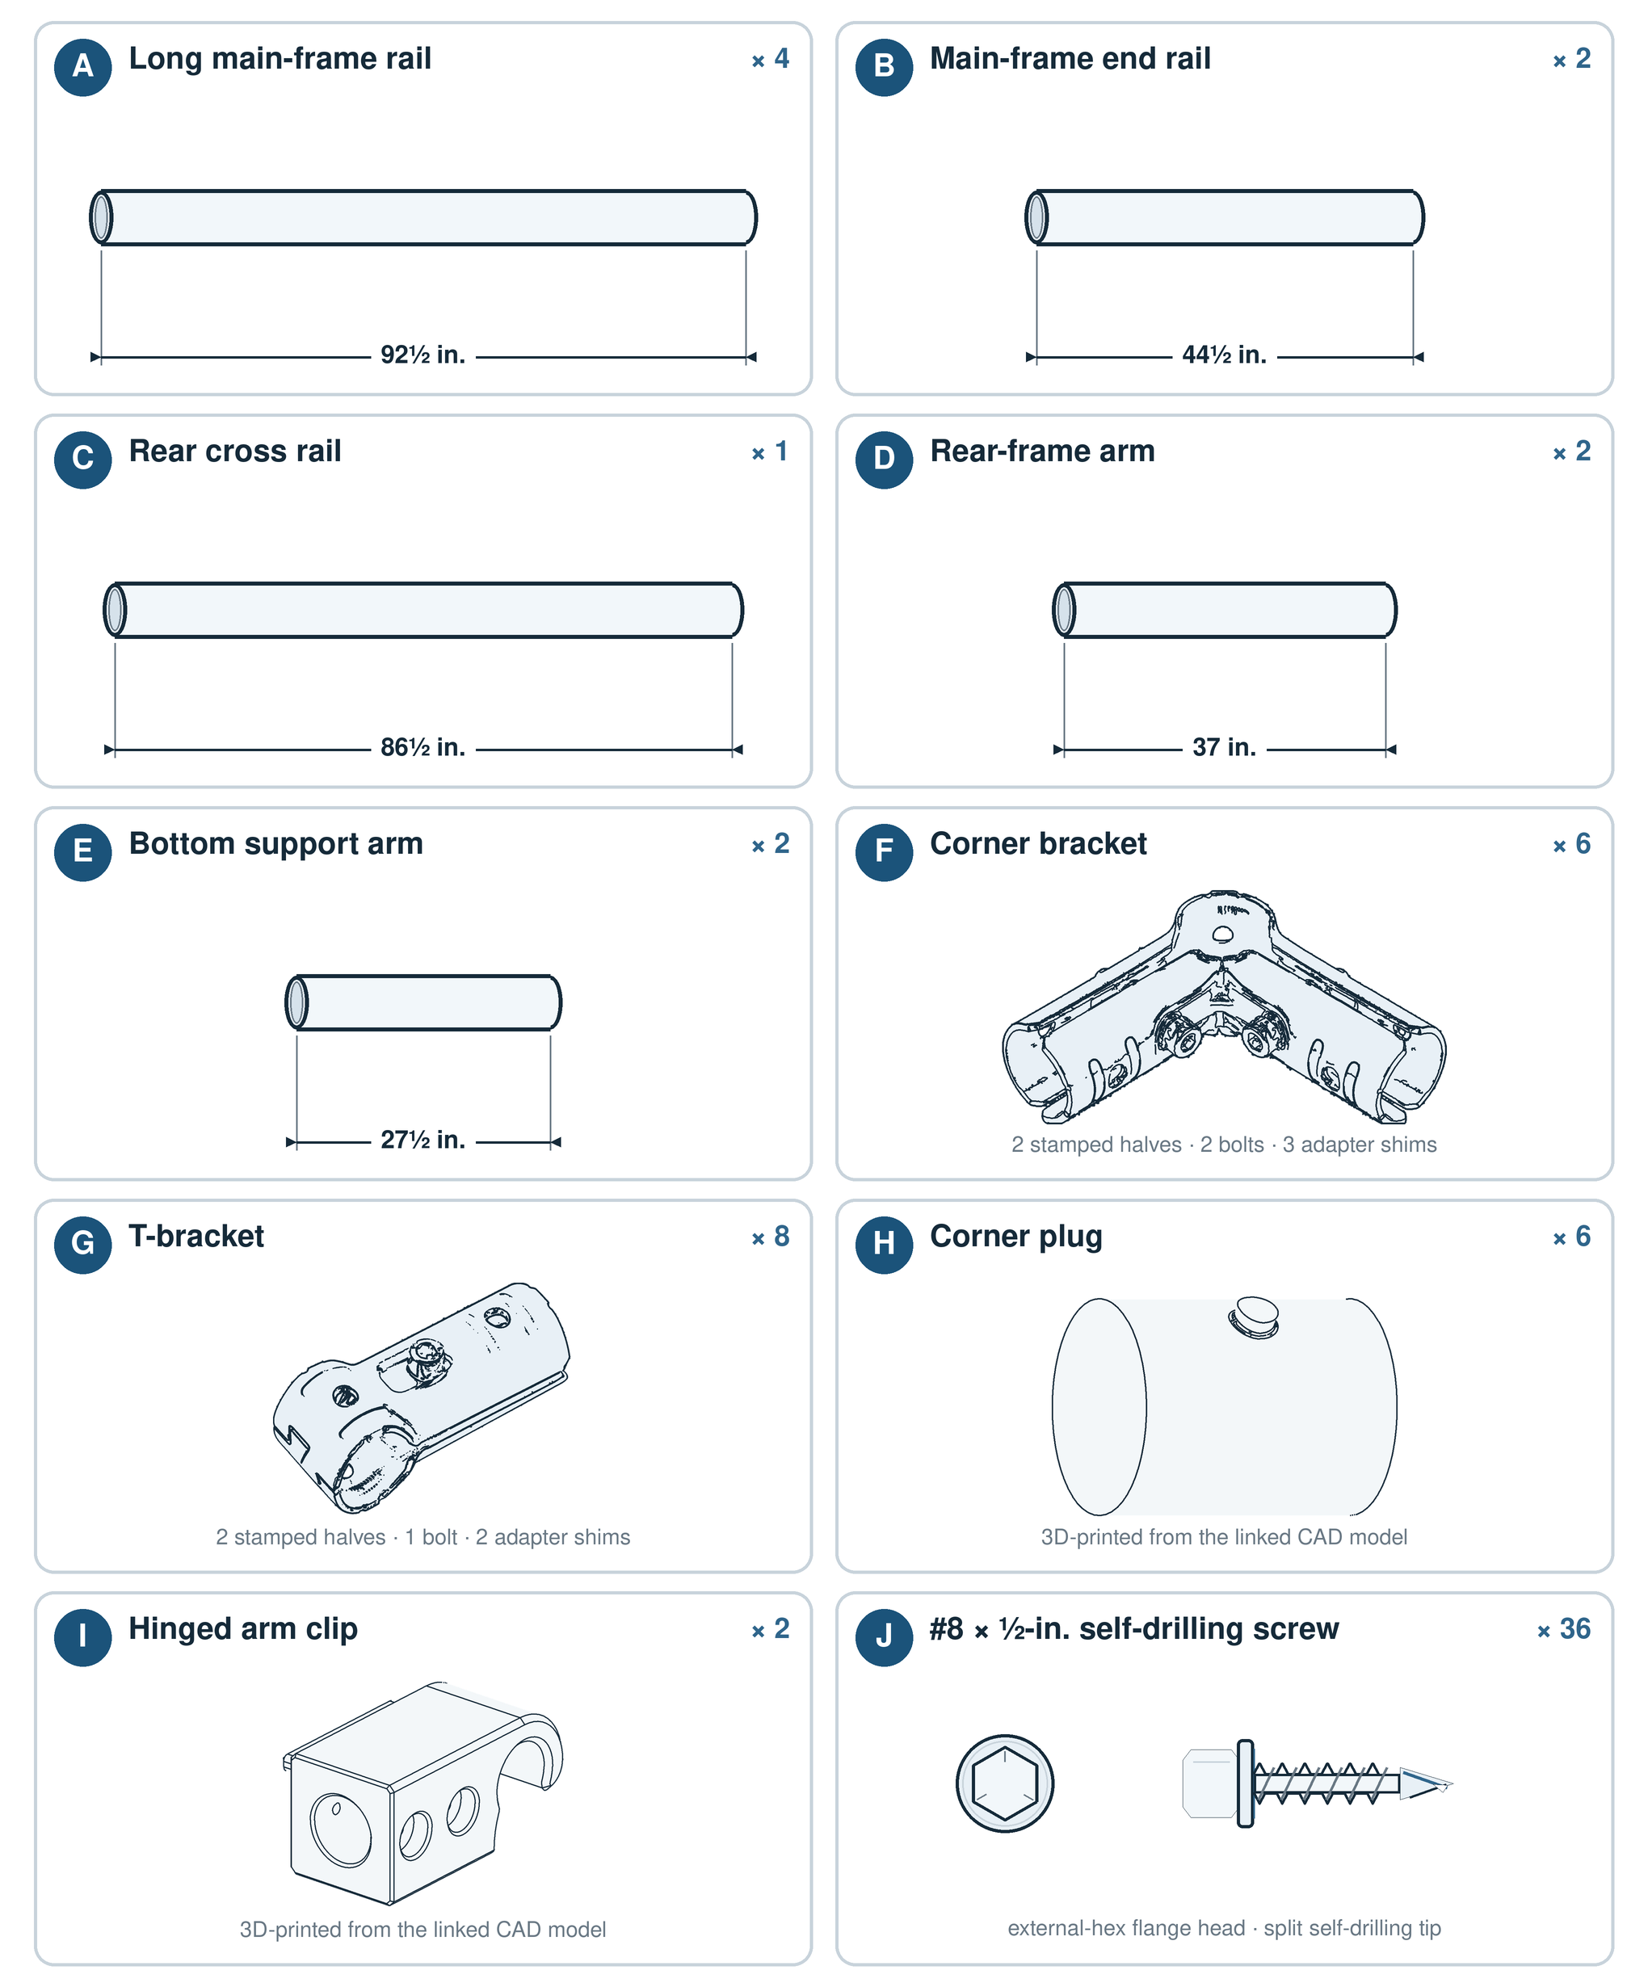
Figure 1. Component inventory for one complete frame.
Identification note: Drawings are not measuring templates and items are not shown at a common scale. The written dimensions and quantities control.

Tools
- EMT conduit cutter
- Tape measure and permanent marker
- Framing square or a tape measure long enough to compare frame diagonals
- Deburring tool or metal file
- 5 mm Allen key
- Drill/driver with a 3/8-in. nut-driver bit
- Eye protection and work gloves
- 3D printer capable of printing ASA, unless the printed parts are prepared in advance

3D-printed parts
Black ASA is the recommended material. Polymaker ASA has provided adequate strength and UV stability in band-prop service for three seasons. PETG may be substituted, but strength varies substantially by brand and formulation; print and load-test a sample before producing all structural parts. Previous Sunlu PETG feather bases fractured in service.
Material restriction: Do not use PLA or ABS for these parts because neither is suitable for prolonged outdoor UV exposure.

Optimized conduit cut plan
The following plan produces every required tube from seven 10-ft stock lengths and does not depend on the nominal 27.5-in. remainder from a 92.5-in. cut. This leaves allowance for normal cutting loss. Keep every finished piece within 1/8 in. of its specified length.
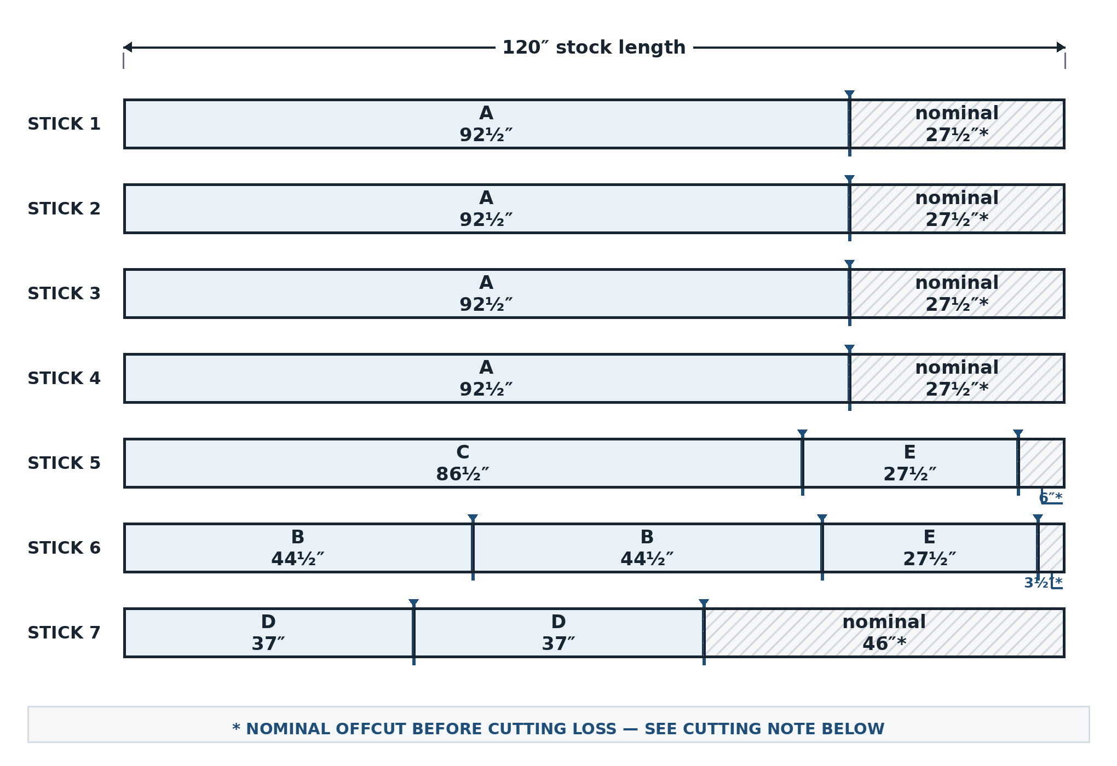
Figure 2. Proportional seven-stick conduit cut diagram.
Cutting note: Gray areas are nominal remainders before cutting loss. Measure every retained piece from a clean stock end. Do not use the nominal 27.5-in. remainder after an A cut as an E arm.

Detailed cut list
Stock length | Retained cuts | Approximate remainder
1 | 1 x 92.5 in. (A) | About 27.5 in.; spare/offcut
2 | 1 x 92.5 in. (A) | About 27.5 in.; spare/offcut
3 | 1 x 92.5 in. (A) | About 27.5 in.; spare/offcut
4 | 1 x 92.5 in. (A) | About 27.5 in.; spare/offcut
5 | 1 x 86.5 in. (C) + 1 x 27.5 in. (E) | 6 in., less cutting loss
6 | 2 x 44.5 in. (B) + 1 x 27.5 in. (E) | 3.5 in., less cutting loss
7 | 2 x 37 in. (D) | 46 in., less cutting loss

Cutting procedure
- Label the seven 10-ft stock lengths 1-7.
- Mark every retained cut before cutting. Verify the complete cut plan before starting.
- Cut each tube to length. Measure the finished piece rather than assuming an offcut is exact.
- Deburr the inside and outside edges of every cut.
- Label the finished tubes A-E so they can be identified during assembly.
When building multiple screens, pool and label usable offcuts before purchasing additional stock.

Estimated fabrication cost breakdown
The following tables itemize estimated material costs per sideline screen and for the planned rolling transport cart based on standard off-the-shelf retail hardware pricing (excluding custom printed vinyl):

Per Sideline Screen / Duck Blind (Excl. Vinyl)
Component / Category | Items Included | Est. Cost
Conduit Framing | 7x 3/4" x 10-ft EMT conduit sticks (Home Depot SKU 0550110000) | $40.50
Corner Brackets (F) | 6x 3/4" 3-way corner brackets (Amazon B0D5BBKCKG) | $27.00
T-Brackets (G) | 8x 3/4" EMT T-brackets (Amazon B0CKQW11SJ) | $23.00
Fasteners (J) | 36x #8 x 1/2" hex flange self-drilling screws | $4.00
3D-Printed Parts | 6x Plugs H, 2x Clips I, 2x Weight Clips in Black ASA | $10.00
TOTAL PER SCREEN | Complete folding screen frame | ~$105.00

Sideline Screen Transport Cart (Component 2 Estimate)
Subsystem / Category | Items Included | Est. Cost
Rolling Base Chassis | Backdrop-spec 2x4 framing, 1/2" plywood deck, 4x casters w/ brakes, paint | $155.00
Side Guide Rails | Vertical framing / conduit dividers to hold screens upright | $35.00
Front & Rear Retention Gates | Hinged gate framing, strap/barrel hinges, and 3D-printed latches | $30.00
TOTAL PER TRANSPORT CART | Complete rolling transport cart | ~$220.00

Frame assembly
Complete the four stages in order. At every hinge location, fasten the bracket to the short moving tube only; never drive a screw into the long rail around which the bracket must rotate.

Folded-state connection map
Use Figure 3 to identify the finished folded arrangement, then use Figure 3A to see how the individual members and connectors align before beginning Stage 1. Both drawings use the same component labels and connector color key. Tube width and separation distances are enlarged for clarity.
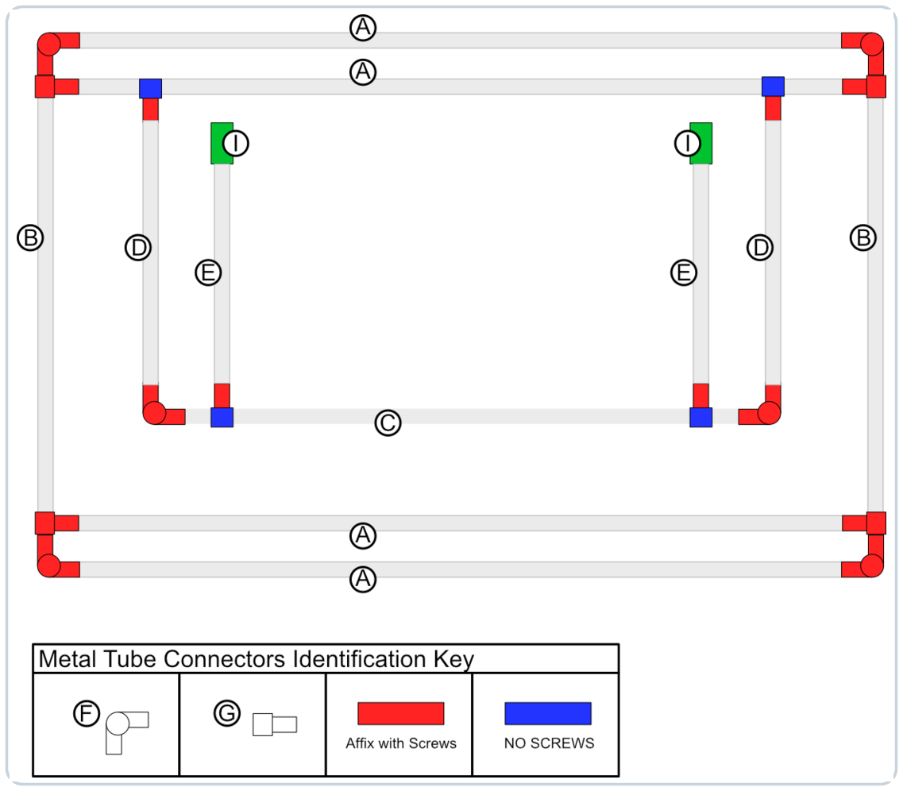
Figure 3. Folded-state component and connector-fastening map for the finished frame.

Exploded folded-state component view
Use this exploded view to identify every construction component in the folded assembly. The separated member ends show how the A-E tubes align with the F and G connectors. Red markers identify connections that receive Item J screws, blue markers identify interfaces that must remain unfastened to pivot, and green blocks identify the two Item I hinged arm clips. Individual Item J fasteners are intentionally omitted.
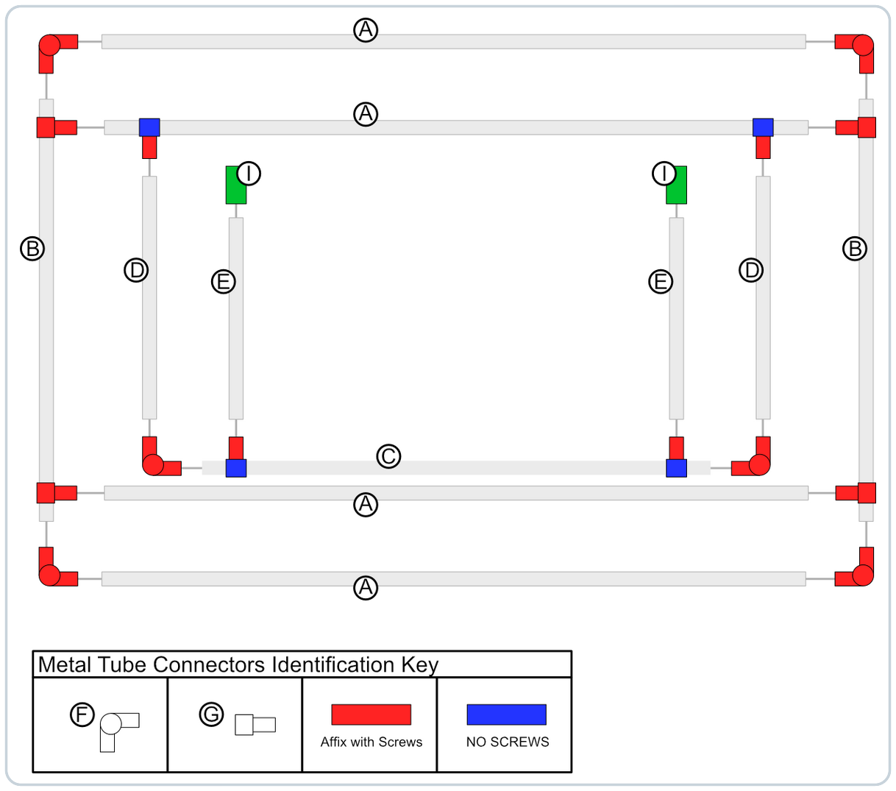
Figure 3A. Exploded folded-state component and connector-fastening map.

Connection rules
Affix with screws — At every red connector marker, secure the connection from the inside or rear face with Item J self-drilling screws, using the quantity and locations specified in the applicable build stage.
No screws — At every blue connector marker, do not drive an Item J screw into the tube that must remain free to pivot. Install the specified screws only on the red-marked fixed side of the connector.
Protect the vinyl — Orient every Item J screw head, T-bracket nut, and bolt tail toward the inside or rear of the assembly, away from the finished face and vinyl.

Stage 1: Assemble the main frame
Parts for this stage
- 2 x A rails
- 2 x B rails
- 4 x F corner brackets
- 4 x H corner plugs
- 8 x J screws
- Lay two A rails and two B rails on the flat work surface to form a rectangle.
- Join the tubes with four F corner brackets. Insert one H corner plug into each unused third socket, rotating it so the side peg faces the rear and aligns with the hole on the bracket's outside bend.
- Measure both diagonals. Adjust the frame until the diagonal measurements are equal, then tighten all bracket-retaining bolts.
- Install one J screw at each of the eight tube-to-bracket joints. Drive the screws from the inside edge of the rectangle so no screw head faces the finished face.
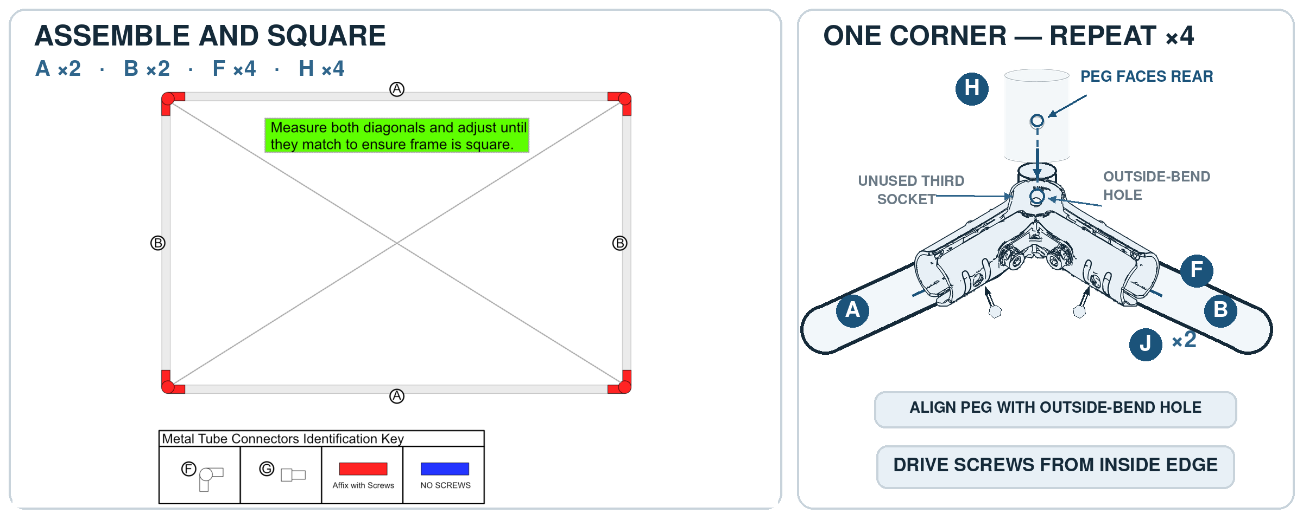
Figure 4. Stage 1 main-frame assembly and corner detail.

Stage 2: Install the inner cross rails
Parts for this stage
- 2 x A rails
- 4 x G T-brackets
- 8 x J screws
Fastener orientation: Place the T-bracket nuts and bolt tails on the rear face. The front/finished face must remain free of sharp projections that could damage the vinyl.
- Place one A rail immediately inside the top A rail and the other A rail immediately inside the bottom A rail.
- Attach each end of both A rails with a G T-bracket. Insert each bracket bolt from the finished face toward the rear so the nut is on the rear face, then tighten fully.
- Flip the main frame so the rear face is up.
- Drive one J screw through each of the eight tube-to-T-bracket interfaces from the rear face.
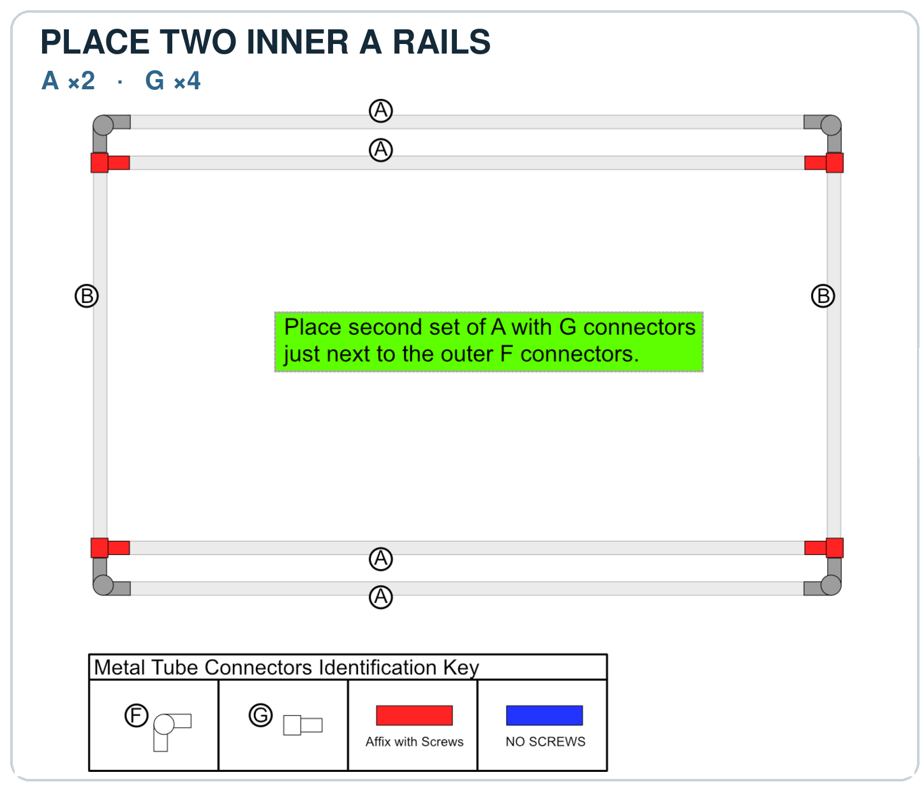
Figure 5. Stage 2 inner-rail placement and T-bracket fastening.

Stage 3: Assemble and attach the rear support frame
Parts for this stage
- 2 x D arms
- 1 x C rear cross rail
- 2 x F corner brackets
- 2 x G T-brackets
- 2 x H corner plugs
- 8 x J screws
Critical hinge rule: Each G bracket in this stage must pivot around the upper A rail. Install two screws in each D arm, but no screws in the A rail.
- Flip the main frame so the finished face is up. No additional self-drilling screws will be driven through the finished face.
- Choose either long edge as the top and mark it. The upper inner cross rail is the second A rail from the top.
- Attach one D arm near each end of the upper inner cross rail with a G T-bracket. Position each new bracket immediately inside the previously installed bracket at that end.
- At each G T-bracket, drive two J screws into the D arm only (four screws total). Do not drive screws into the A rail; the bracket must rotate freely around that rail.
- Join the free ends of the two D arms with the C rear cross rail, two F corner brackets, and two H corner plugs.
- Square the rear support frame and tighten both corner brackets.
- Install two J screws at each rear-frame corner (four screws total), placing them on the inside of the corner. Stage total: eight screws.
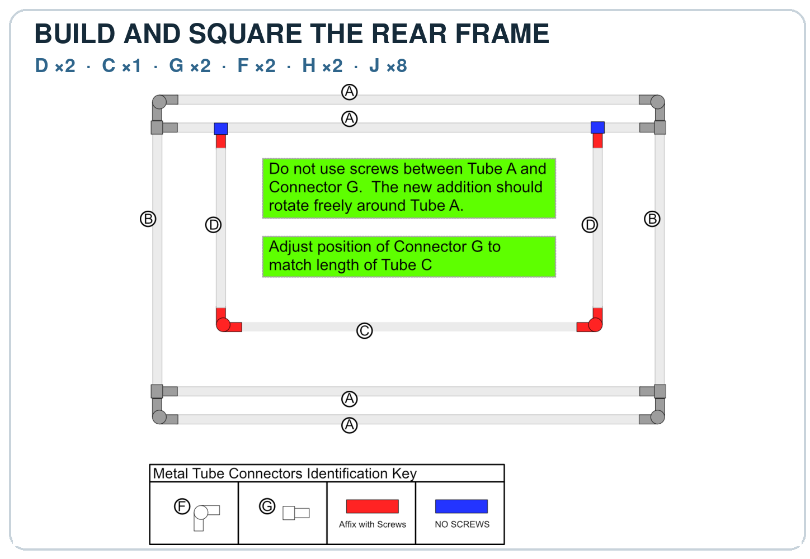
Figure 6. Stage 3 rear-support-frame assembly and hinge fastening.

Stage 4: Install the bottom support arms
Parts for this stage
- 2 x E support arms
- 2 x G T-brackets
- 2 x I hinged arm clips
- 12 x J screws
Critical hinge rule: Each G bracket in this stage must pivot around the C rear cross rail. Install screws in the E arms only; do not fasten either bracket to the C rail.
- Attach one E support arm near each end of the C rear cross rail with a G T-bracket. Position each new bracket immediately inside the adjacent corner bracket and tighten the bracket bolts.
- At each G T-bracket, drive two J screws into the E arm only (four screws total). Do not drive screws into the C rail; the bracket must rotate freely around that rail.
- Stand the assembly upright with both E support arms lying on the ground.
- Fit one I hinged arm clip onto the free end of each E arm. Engage both clips with the lower inner cross rail, which is the third long rail from the top and the second from the bottom.
- Make each clip square to the lower inner cross rail and confirm that it is fully seated on its E arm.
- Drive four J screws through each hinged arm clip into its E arm (eight screws total). Start with the accessible outside pair, disengage the clip, and install the remaining two screws. Stage total: twelve screws.
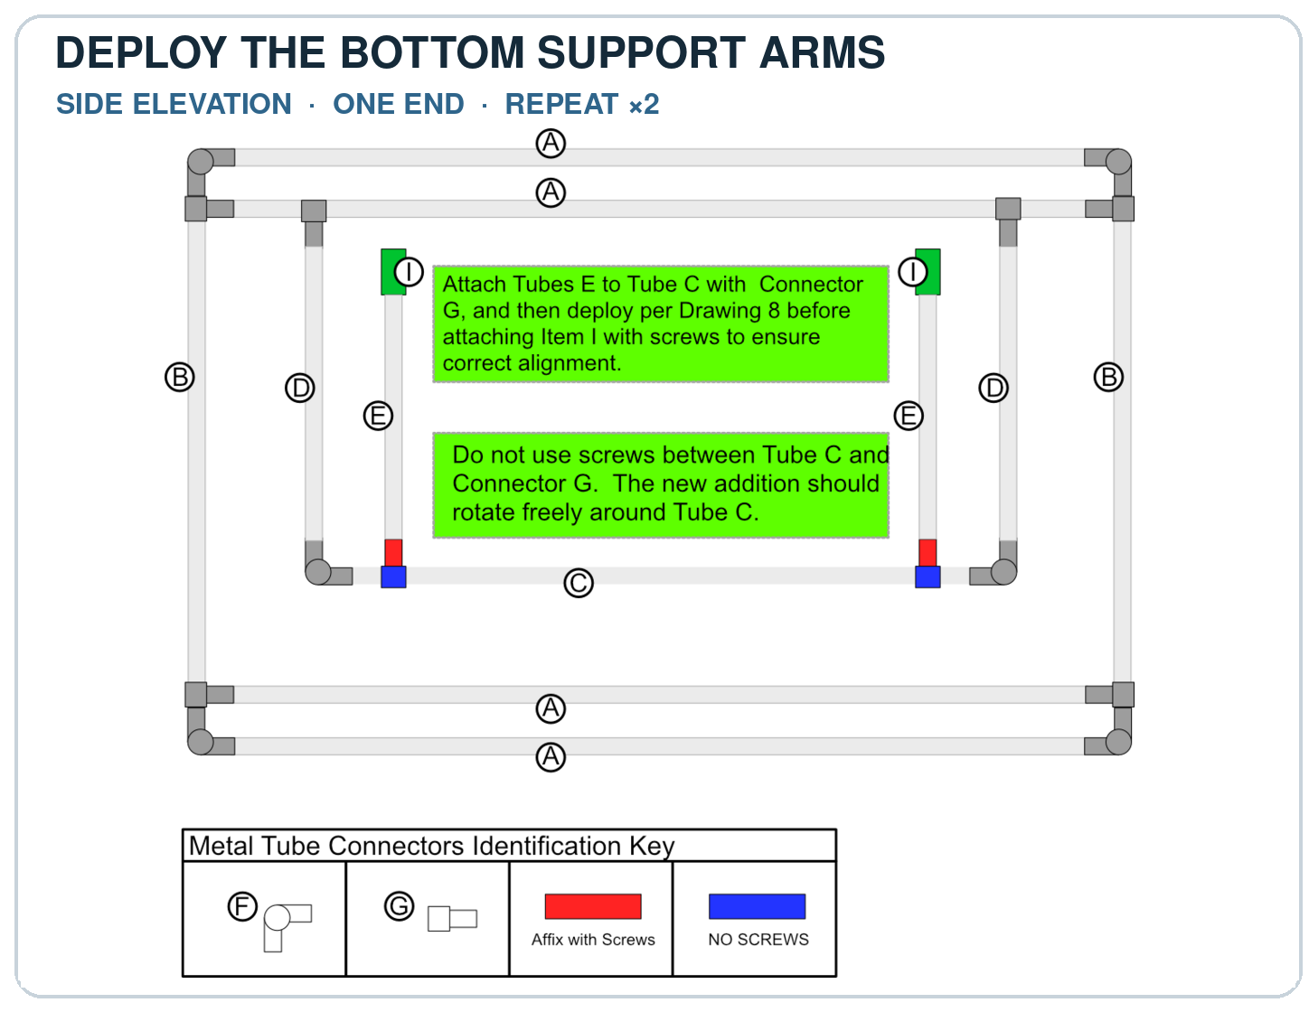
Figure 7. Stage 4 bottom-support-arm installation and clip fastening.
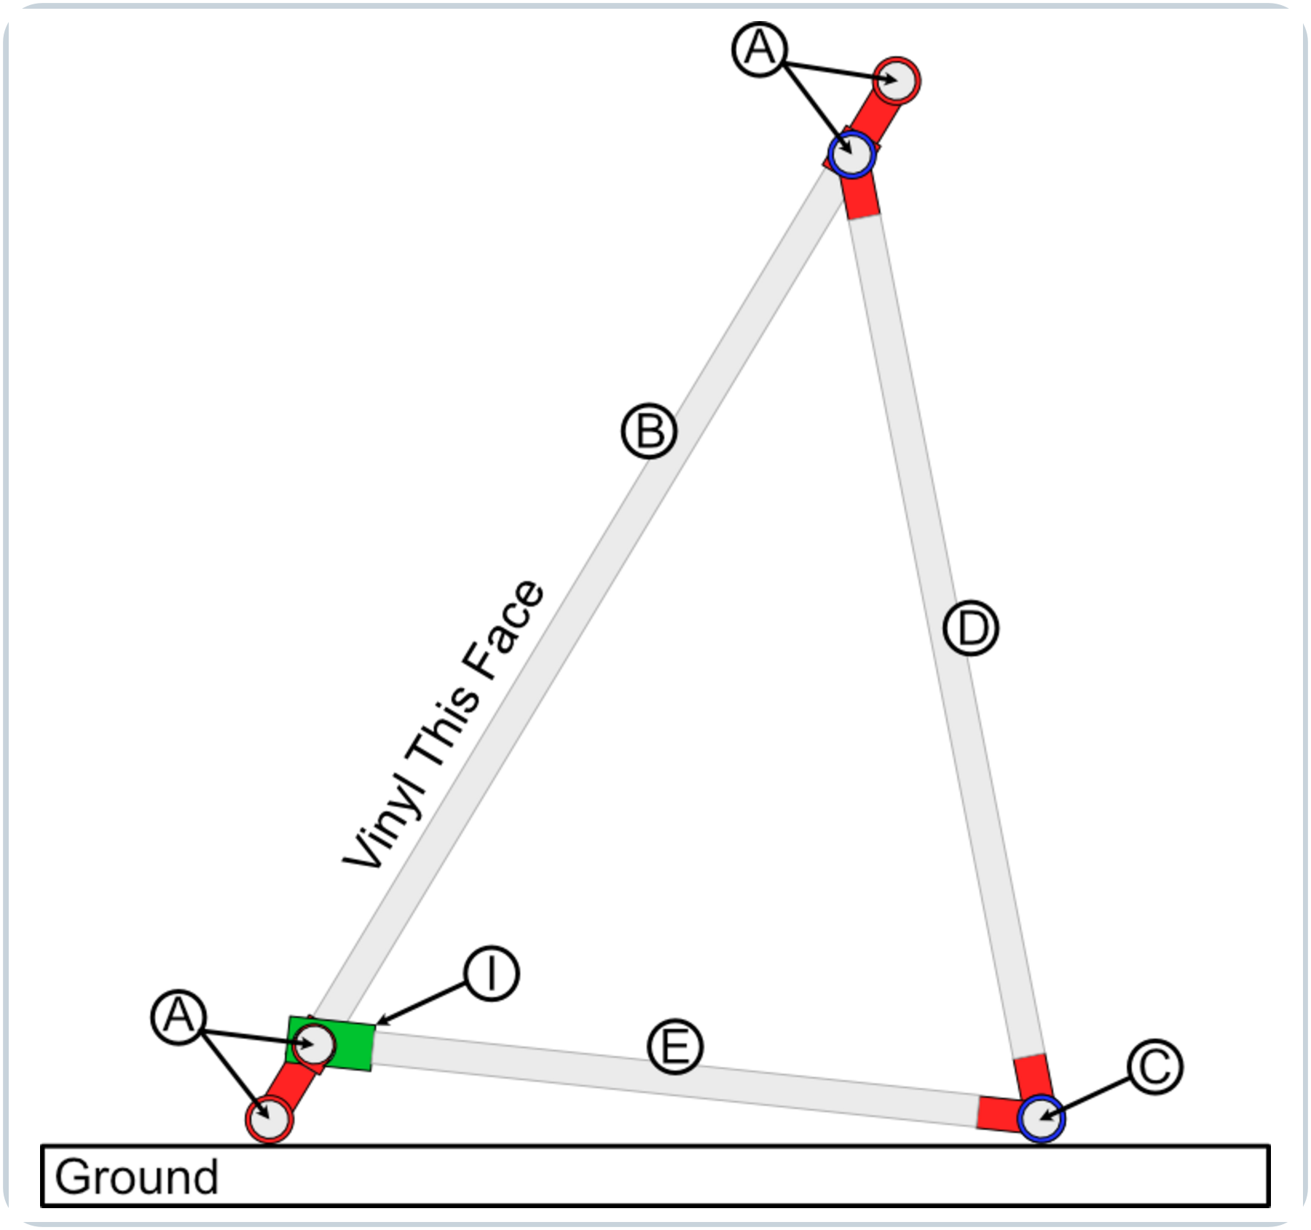
Figure 8. Deployed cutaway side elevation showing the B foot and C/E connection.

Final construction inspection
- All 36 self-drilling screws are installed in the specified locations.
- No screw head, bracket nut, bolt tail, burr, or other sharp projection faces the future vinyl surface.
- Both rear-frame hinges rotate around the upper inner rail without binding.
- Both bottom-support hinges rotate around the rear cross rail without binding.
- Both hinged arm clips engage and disengage without excessive force.
- All retaining bolts are tight, and every structural corner is as square as practical.
- The frame can be unfolded, locked open with both clips, released, and folded flat.

Transport Cart Fabrication (Planned Component)
To support efficient field transport and rapid deployment during competitive shows, a dedicated rolling transport cart will be constructed to hold multiple folded sideline screens / duck blinds:
• Backdrop Cart Base Compatibility: The transport cart utilizes the same heavy-duty 96.0 in. x 44.5 in. 2x4 lumber base framing, 1/2-in. plywood decking, and four heavy-duty swivel plate casters standardized for the Rolling Backdrop System. Building on this shared chassis ensures dimensional consistency and uniform trailer nose wall loading.
• Side Guide Rails: Vertical guide rails are mounted along both the left and right longitudinal edges of the cart bed to contain folded sideline screens standing upright in parallel slots during rolling transit.
• Front & Rear Latching Gates: Hinged retention gates are installed across the front and rear openings of the cart. The gates are secured with 3D-printed Cart Gate Latches (Cart Gate Latch.FCStd) to lock screens firmly inside the cart bed while allowing quick release and unobstructed unloading at the field sideline.
• Internal Nesting Capacity (8 Screens / 16.0 Inches): Because each screen is engineered with coplanar internal nesting and folds to no more than 2.0 inches thick (the thickest feature being the 3D-printed hinged arm clip I), eight folded screens occupy only 16.0 inches of the 44.5-inch cart bed width. This leaves over 28 inches of deck width for dedicated sandbag ballast compartments, slot dividers, and auxiliary equipment storage.
• Status: Provisional design specification. Detailed CAD models, cut lists, and fastener schedules for the transport cart modifications will be finalized in subsequent build releases following prototype testing.

Vinyl Installation
Section status: Working draft procedure for vinyl installation using perimeter double-sided tape and mechanical greenhouse snap clamps. Recommended vinyl dimensions (image size, bleed size, overall cut size) and tape strip quantities are provisional and subject to shop fit-up confirmation.
This section governs the preparation, alignment, dual-axis tensioning, and mechanical fastening of the custom printed vinyl coverings to completed sideline screen frames. Installing vinyl on the folding frame requires a clean staging area, careful bleed centering, double-sided tape adhesion, and mechanical clamping with greenhouse snap clamps to prevent loosening under high field wind loads.

Recommended Vinyl Dimensions & Ordering Specifications
Sideline screen face coverings are custom-ordered commercial vinyl banners. Because the screens are positioned directly along the field boundary facing stadium audiences and adjudicators, the printed artwork must be oriented right-reading and centered precisely across the outer EMT conduit frame.
Dimension Parameter | Recommended Value | Engineering & Fit Specification
Nominal Frame Outer Bounds | 48.0 in. H x 96.0 in. W | Nominal outer dimensions of perimeter 3/4-in. EMT rectangular frame (tubes A and B).
Live Image Size (Visual Area) | TBD (Nominal ~46" x ~94") | Front face graphic area visible to audience and judges; centered within outer tubing perimeter.
Bleed Allowance (Wrap Margin) | TBD (Nominal ~2.5" per edge) | Extended background bleed color wrapped around 3/4-in. EMT conduit to adhere to rear tape strips.
Overall Flat Cut Size | TBD (Nominal ~53" x ~101") | Total flat dimensions of ordered banner before edge wrapping, tensioning, and clamp installation.
Substrate Material & Weight | Heavyweight scrim vinyl | 13 oz. or 18 oz. tear-resistant outdoor banner vinyl with non-glare matte finish.
Edge Finishing Specification | Flush straight cut | Square raw-cut perimeter; DO NOT order hemmed borders or brass grommets, as raw edges wrap smoothly under snap clamps.
Dimensional specification note: Exact custom dimensions—including visual image size, wrap-around bleed margin, and overall cut size—are currently provisional (TBD). Specific numerical values will be updated in the technical specifications following prototype field stretch testing.

Required Materials & Fastening Hardware
Assemble all necessary staging items, adhesive consumables, and retention hardware before initiating vinyl mounting on a frame:
• Moving blankets: Two to three clean, heavy-duty moving blankets or carpet runners spread across the shop floor to cushion the printed vinyl face against dust, grit, and concrete abrasion.
• Custom vinyl banner: One custom printed outdoor banner per screen, rolled with print side facing inward. Unroll and inspect for print flaws and correct orientation prior to assembly.
• Double-sided tape: 1-in. wide heavy-duty outdoor mounting tape (Appendix B Index [9]). Cut into sixteen (16) strips of approximately 4-in. length (~64 linear inches per screen). Application schedule: 5 strips on each long rail (10 total) and 3 strips on each short rail (6 total). Tape quantities are provisional (TBD) and will be validated during build testing.
• Greenhouse snap clamps: Sixteen (16) 1-in. greenhouse clamp clips (Appendix B Index [8]). Snapped directly over the wrapped vinyl at every tape location (5 along each long rail, 3 along each short rail). Note: While the frame uses 3/4-in. trade size EMT conduit, EMT has an actual outer diameter of approximately 0.922 in. (nearly 1 in. OD); wrapped with vinyl and tape, 1-in. greenhouse snap clamps provide the proper snug snap fit.
• Surface preparation (Optional): Isopropyl alcohol (IPA) and clean microfiber cloth. Degreasing the conduit is completely optional—the heavy-duty tape combined with mechanical greenhouse snap clamps provides more than enough holding power. A weaker initial adhesive bond to the bare conduit is actually preferable, as it significantly simplifies tape removal and cleanup later.
• Personnel: Two (2) persons minimum for staging and long-side wrapping; three (3) persons recommended during short-side tensioning so opposite ends can be pulled simultaneously.

Step-by-Step Vinyl Installation Procedure

Step 1: Staging and Surface Protection
Thoroughly sweep and vacuum a clean, flat floor area measuring at least 10 ft x 14 ft. Lay moving blankets flat across the entire work zone to prevent grit from scratching the printed graphic.
Carefully unroll the custom vinyl banner face down directly on top of the moving blankets. Inspect the reverse side for cleanliness and smooth out any major packing rolls.

Step 2: Frame Placement and Bleed Alignment
Carry the assembled sideline screen frame (in folded transport configuration) onto the vinyl and place it face down centered over the material.
Shift the frame until there is an even, equal reveal of perimeter bleed wrap margin on all four sides (top, bottom, left, and right outer rails). Verify that the frame is resting completely square on the vinyl prior to applying any tape.

Step 3: Perimeter Double-Sided Tape Application
Cut sixteen (16) strips of 1-in. heavy-duty double-sided tape, each approximately 4 inches in length.
Apply the tape strips to the rear-facing surface of the perimeter EMT conduit in the following layout:
• Long rails (Top and Bottom A rails): Apply 5 strips spaced evenly along each rail (one centered, two at intermediate quarter points, and two approximately 3 inches inward from the corner brackets; 10 strips total).
• Short end rails (Left and Right B rails): Apply 3 strips evenly spaced along each rail (one centered and two approximately 3 inches inward from the corner brackets; 6 strips total).
Burnish each tape strip firmly onto the conduit surface, then peel and discard the protective release liners from all 16 strips.

Step 3.1: Cutting Engineered Wind Relief Slits (Optional / High-Wind Venues)
For venues with frequent high-wind conditions (such as Colorado Springs), cutting engineered inverted-U wind relief slits into the upper zone of the vinyl banner significantly enhances aerodynamic stability by bleeding peak gust dynamic pressure and reducing the net drag coefficient from Cd = 1.20 to Cd = 1.02.
• Mandatory Tear-Arrest Relief Holes: NEVER cut a sharp razor corner into scrim vinyl without first punching circular relief holes. Sharp internal corners act as severe stress risers (Kt >= 3.0), leading to banner tearing under wind flutter. Use a sharp 3/8-in. (10 mm) rotary leather punch or gasket punch to create clean circular holes at both upper hinge corners before cutting.
• Crescent Flap Geometry: Cut 4 to 6 inverted-U crescent flaps (6.0 in. to 8.0 in. wide with a 4.0 in. to 5.0 in. downward curved drop) across the upper zone of the banner (between Rail 1 and Rail 2). Gravity keeps the flaps flush and invisible from the audience in calm air, while wind pressure pushes flaps open to vent gusts.

Step 4: Long-Side Tensioning and Initial Wrap
Start along one designated long side (typically the top A rail). Beginning at the center tape strip and progressing outward toward both corners, fold the vinyl bleed margin tightly around the conduit and press it firmly into the 5 double-sided tape strips on the rear of the tube. Check that the graphic remains aligned with the outer tubing edge.
Move to the opposing long side (bottom A rail). Starting at the center and working outward, pull the vinyl firmly across the frame face to eliminate all slack and wrinkles. Fold the vinyl edge tightly around the bottom conduit and press it securely into the 5 opposing tape strips.
Sight down the front face beneath the frame: confirm that longitudinal tension is smooth and uniform, with no wave patterns or diagonal wrinkling.

Step 5: Short-Side Dual-Operator Tensioning and Wrap
Station one person at each of the two short end rails (B rails).
Working simultaneously, both operators firmly grasp the vinyl bleed margin on opposite ends and pull outward in opposing directions away from the center. This synchronized outward pull establishes balanced transverse tension across the entire width of the screen without pulling the frame out of square.
While maintaining continuous outward tension, wrap the vinyl edges over the short end rails and press them firmly into the 3 tape strips on each side.
Neatly fold the excess vinyl corner tabs around the corner brackets (F), flattening the material to maintain clean, square corners without bulky bunches.

Step 6: Greenhouse Snap Clamp Installation
Install the 1-in. greenhouse snap clamps directly over the wrapped vinyl at every tape location, pressing each clamp firmly over the conduit until it snaps into full mechanical lock:
• Long rails: Install 5 snap clamps on the top rail and 5 snap clamps on the bottom rail (10 clamps total).
• Short end rails: Install 3 snap clamps on each of the two short end rails (6 clamps total).
The 1-in. greenhouse snap clamps compress the vinyl tightly against the tape and 3/4-in. EMT conduit, providing heavy-duty mechanical clamping that prevents tape peel or edge detachment under stadium wind gusts or rough trailer transit.
Confirm that no snap clamp interferes with the pivoting rear-support G-brackets, bottom support arm clips (I), or corner plugs (H).

Step 7: Final Tension and Mechanical Clearance Inspection
With two operators, carefully lift the completed sideline screen upright off the moving blankets.
Inspect the front vinyl face in bright lighting: verify that the graphic is drum-tight, square, free of wrinkles or sagging, and centered within the visible frame opening.
Verify that all 16 greenhouse snap clamps are fully seated and firmly gripping the conduit over each tape strip.
Deploy the rear support frame (C/D) and engage both bottom support arm clips (I) into the lower inner rail (Figure 8). Confirm that the wrapped vinyl and snap clamps do not bind, rub, or impede frame deployment, clip latching, or folding flat for transport.

Vinyl Removal & End-of-Season Teardown Protocol
CAUTION — Temperature Requirement for Vinyl Removal: Do not attempt removal of the vinyl or adhesive tape unless the ambient temperature is above 80°F (27°C). Attempting to peel the vinyl at lower temperatures will cause the material to tear and permanently damage the custom banner face. In cooler weather, warm the shop or gently heat the taped perimeter with a heat gun on low before peeling.
When taking down screens or preparing frames for graphic replacement:
• Recommended timing (Defer to Band Camp): It is usually much easier to leave the vinyl on the frames over the winter and wait until summer band camp of the following season before attempting removal. Cold late-fall temperatures following competition season make adhesive stiff and brittle, drastically increasing tear risk.
• Solar heating advantage: The warmer it is outside, the better. Staging the screens outdoors in direct sunlight for just a few minutes prior to peeling warms the conduit and softens the tape adhesive, allowing the vinyl and tape to release cleanly and effortlessly with minimal pull resistance.
• Remove greenhouse snap clamps: Carefully pry off all 16 greenhouse snap clamps from the perimeter tubing.
• Peel slowly at shallow angle: Starting at one corner, slowly peel the vinyl wrap back at a shallow angle. Warm adhesive releases cleanly from the bare EMT conduit without pulling the scrim or ink layer.
• Tape stripping & cleanup: Peel remaining tape strips from the conduit. Because the conduit was not aggressively degreased during initial assembly, tape strips will pull off cleanly with minimal adhesive residue.

Appendix B Index
This index applies to Appendix B. Use the numbered references in the Appendix B component table to locate purchase sources, print material, and digital part files. In the digital manual, select a descriptive link. For a printed copy, the complete URL is shown beneath each link.

Purchase sources
[1] 3/4-in. x 10-ft EMT conduit - Home Depot
https://www.homedepot.com/p/3-4-in-x-10-ft-Electrical-Metallic-Tubing-EMT-Conduit-0550110000/202068040
[2] Corner brackets - Amazon
https://www.amazon.com/dp/B0D5BBKCKG
[3] T-brackets - Amazon
https://www.amazon.com/dp/B0CKQW11SJ
[4] #8 x 1/2-in. self-drilling screws - Home Depot
https://www.homedepot.com/p/Teks-8-x-1-2-in-External-Hex-Flange-Hex-Head-Self-Drilling-Screws-280-Pack-21308/100188836
[5] Black ASA filament - Amazon
https://www.amazon.com/dp/B09TR84J5M
[8] Greenhouse snap clamps (1-in.) - Amazon
https://www.amazon.com/dp/B0BJJYKZ5L?th=1
[9] Heavy-duty double-sided tape - Amazon
https://www.amazon.com/dp/B07BBL4JXJ/?th=1

Digital part files
[6] Corner plug digital files
FreeCAD source file
https://github.com/ericrowe/music/blob/7ab68c66b4ecbd72d9e039212acab02a002df1bb/PCHSMB/_Sideline%20Screen/Corner%20Plug.FCStd
STEP file
https://github.com/ericrowe/music/blob/7ab68c66b4ecbd72d9e039212acab02a002df1bb/PCHSMB/_Sideline%20Screen/STEP/Corner%20Plug-Part.step
3MF print file
https://github.com/ericrowe/music/blob/7ab68c66b4ecbd72d9e039212acab02a002df1bb/PCHSMB/_Sideline%20Screen/3MF/Corner%20Plug-Part.step.3mf
[7] Hinged arm clip digital files
FreeCAD source file
https://github.com/ericrowe/music/blob/7ab68c66b4ecbd72d9e039212acab02a002df1bb/PCHSMB/_Sideline%20Screen/Hinged%20Arm%20Clip.FCStd
STEP file
https://github.com/ericrowe/music/blob/7ab68c66b4ecbd72d9e039212acab02a002df1bb/PCHSMB/_Sideline%20Screen/STEP/Hinged%20Arm%20Clip-Part001.step
3MF print file
https://github.com/ericrowe/music/blob/7ab68c66b4ecbd72d9e039212acab02a002df1bb/PCHSMB/_Sideline%20Screen/3MF/Hinged%20Arm%20Clip-Part001.3mf
[11] 2026 Colorado Bandmasters Association (CBA) Marching Band Rulebook (PDF)
https://ebf5c7e8-3869-4325-bd98-ce10f57d7545.filesusr.com/ugd/83f67e_cb5fe6efdbdb4ce98f619580f694bc94.pdf

APPENDIX C: FIELD OPERATIONS PLACARD
One-Page Laminated Field Reference for Trained Student Handlers & Parent Pit Crew
ATTACH 4" × 6" FIELD PLACEMENT / DRILL CARD HERE
(Exact 6.0" wide × 4.0" high mounting area for season-printed laminated drill card from Appendix C.1)
Screen #: _____ of 16 | Show Segment: _________________ | Side: [ ] Side 1 (Left) [ ] Side 2 (Right)
Front Sideline Coordinate: _______________________________________________________________
Assigned Handlers (Min. 2): 1) _______________ 2) _______________ 3) _______________

1. Wind Velocity Limits & Standardized Ballasting Schedule
Tier / State | Wind Velocity | Ballast Deployment (15-lb Bags) | Total Wt | Operational Limits & Action
Tier 0: Calm | 0–8 mph (gusts ≤10) | 0 bags (unballasted dry frame) | 26 lbs | Safe to 8.1 mph fwd / 18.9 mph bwd. Must upgrade to Tier 1 if wind >8 mph.
Tier 1: Normal | 8–12 mph | 1x to 2x bags on rear ground rail C (15–30 lb) | 41–56 lbs | 17.6–23.5 mph max gust fwd. Zero stress on clips (I).
Tier 2: Advisory | 12–18 mph | 2x rear rail C + 1x hanging Rail 2 (45 lb) | 71 lbs | Balanced stability: 23.7 mph fwd / 24.5 mph bwd.
Tier 3: High-Wind | 18–22 mph | 2x rear rail C + 2x hanging Rail 2 (60 lb) | 86 lbs | 24.5–28.4 mph max gust. Zero turf compaction.
Tier 4: ABORT | >20 sust. / >25 gust | — | — | STRICT SAFETY NO-GO. Disengage clips and immediately lay flat.

2. Critical On-Field Safety & CBA Routing Rules
• CBA Rule 5.02 Mandatory Rear Entrance: Props must enter strictly from the back sideline or rear end zone gates (above goal posts). NEVER cross or stage props directly across the front boundary (reserved for pit equipment). Handlers transit around the perimeter to front sideline positions.
• Front Sideline Placement: Position screens on designated yard line marks to either side of the front ensemble. Handlers must be completely clear of the field before the introductory announcement ends (0.2 point penalty under Rule 4.03).
• Ballasting Leverage (Rear Rail C): Always deploy primary sandbags over rear ground rail C first for maximum lever arm against rear wind. For Tier 2/3, hang supplemental bags from Rail 2 using 3D-printed Weight Clips.
• Mandatory Double-Bagging (Rule 8.05): All sandbags must have intact heavy-duty plastic inner liners. Never bring single-layer bags onto athletic turf.
• High-Wind Emergency Lay-Flat: If severe gusts strike (>25 mph), handlers disengage hinged arm clips (I), fold rear support frame flat, and lay screens flat on turf. Adult volunteers with Rule 9.07 wristbands may assist per Rule 4.02(a).

3. Rapid Field Deployment & Teardown Checklist
• Venue Staging & Ingress: Screens are transported fully assembled on cart. Roll cart to rear gate. When T&P judge signals entry permission, roll cart along perimeter to front sideline placement zone.
• Pre-Set Receiver Deployment & Egress: 1) Carts stage on back 20/40 marks; 2) Pushers roll 55 yd straight across field, turn away from exit, and roll dropping blinds; 3) Pre-set students at marks latch frames in parallel (~2:14 setup, banks +60s); 4) Post-show, performers collapse frames, leave ballast on turf (do not throw/drop), and hand-carry frames to exit; 5) Pushers sweep ballast straight toward exit with zero doubling back; 6) Reload carts off-clock in tunnel or lot per Rule 8.05.

APPENDIX C.1: 4" × 6" FIELD PLACEMENT CARD TEMPLATE
Printable & Fillable Coordinate Card for Appendix C On-Prop Placard (Cut along dashed line)
PCHS MARCHING BAND — SIDELINE SCREEN DRILL CARD
Screen #: ____ of 16 | Segment: ___________________ | Side: [ ] Side 1 (Left) [ ] Side 2 (Right)
Front Sideline Coordinate: _________________________________________________________________________
Assigned Handlers (Min. 2): 1) ____________________ 2) ____________________ 3) ____________________
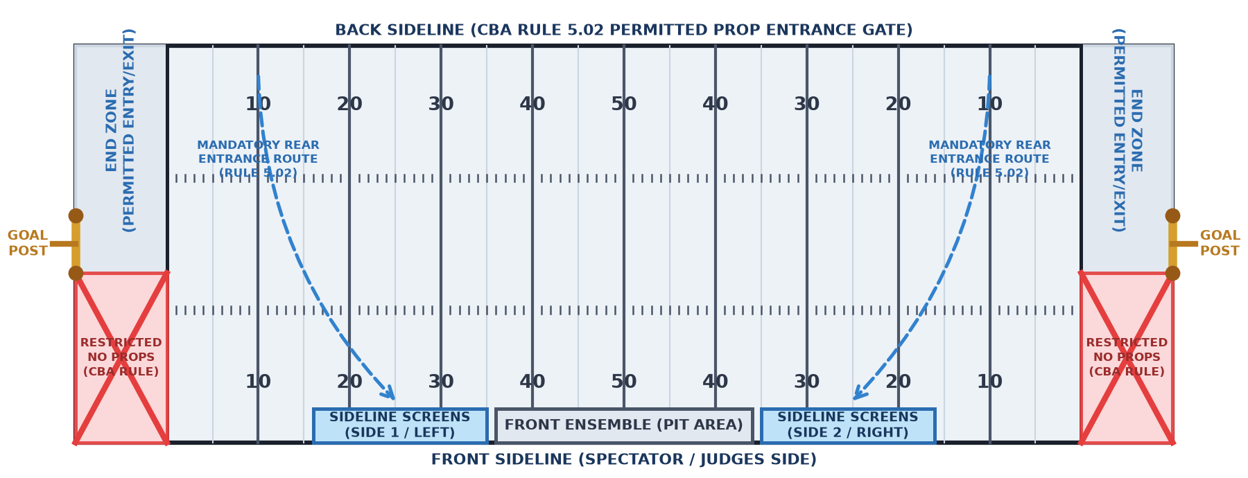
✂ Cut along dashed blue border (exact 6.0" × 4.0" card). Mark prop routes with wet-erase marker, laminate, and attach to placard.

Field Coordinator & Drill Writer Instructions
1. Season Preparation: Coordinate cards are prepared and printed ONCE PER SEASON with all static information at the top filled in (Screen #, Show Segment, Coordinate, Show Side, and assigned handlers). Cut along dashed border, laminate, and mount into the Appendix C placeholder box using hook-and-loop coins.
2. Competition Day Route Marking: On competition day, the ONLY update made to the card is drawing the specific field entrance route, coordinate placement, and exit trajectory arrows directly onto the laminated card using a wet-erase marker.
3. CBA Rule 5.02 Entrance Mandate: Screens must enter from the back sideline or rear end zone gates (above goal posts) and transit around to front sideline coordinates. NEVER enter or stage props in the front end zone below the goal posts (marked with a red 'X'). Maintain continuous egress off field after the show per Rule 8.05.
4. Two-Shot Staging Protocol: Between Prelims and Finals, keep screens folded flat on the transport cart in the trailer lot to eliminate wind sail area while maintaining readiness.

APPENDIX D: PARENT VOLUNTEER COMPETITION DAY GUIDE & FIELD PROTOCOL
One-Page Operational Guide & CBA Rules Compliance for Pit Crew & Prop Volunteers
Event: __________________________________________ | Date: __________________ | Venue / Stadium: __________________________________________

1. Volunteer Schedule, Staging Milestones & Call Times
Milestone / Station | Time | Location & Staging Point | Volunteer Duties & Field Logistics
Trailer Arrival & Spotting | ____:____ AM/PM | Equipment Trailer Lot | Meet trailer, deploy ramps, unstrap transport carts (screens fully assembled).
Cart Staging & Ballast Check | ____:____ AM/PM | Trailer Staging Area | Verify cart gates, staged double-bagged 15-lb sandbags, and 3D Weight Clips.
Pit & Screen Warmup Area | ____:____ AM/PM | Designated Warmup Zone | Assist front ensemble movement; inspect sandbag inner liners (Rule 8.05).
Prop Gate Pre-Stage (Rule 5.03) | ____:____ AM/PM | Back Sideline / Rear Gate | Pre-stage cart in rear half of end zone above goal post; don wristbands (Rule 9.07).
Prelims Ingress & Performance | ____:____ AM/PM | Front Sideline (via Rear Gate) | Enter via rear gate (Rule 5.02), transit around perimeter to front; set; CLEAR FIELD!
Prelims Catch & Continuous Egress | ____:____ AM/PM | Field Exit / Stadium Chute | Performers hand-carry collapsed frames; pushers sweep ballast straight to exit; reload off-clock in lot.
Inter-Show Staging ("Two-Shot") | ____:____ AM/PM | Trailer Staging Lot | Keep screens folded on cart bed in lot between shows; zero wind sail area.
Finals Ingress & Performance | ____:____ AM/PM | Rear Gate / Front Sideline | Don Finals wristbands (new color); await T&P judge; set screens; clear field.
Finals Catch & Trailer Loading | ____:____ AM/PM | Trailer Staging Lot | Continuous egress to trailer; unstrap sandbags; roll carts into trailer; lock gates.
Extra 1: __________________ | ____:____ AM/PM | ________________________ | __________________________________________________________________
Extra 2: __________________ | ____:____ AM/PM | ________________________ | __________________________________________________________________
Extra 3: __________________ | ____:____ AM/PM | ________________________ | __________________________________________________________________
Extra 4: __________________ | ____:____ AM/PM | ________________________ | __________________________________________________________________

2. 2026 CBA Marching Band Rules Governing Adult On-Field Behavior
• Mandatory Field Pass Wristbands (Rule 9.07): Access to the performance field is strictly restricted to designated Field Pass wristbands (maximum 25 per band upon check-in). Wristbands permit access ONLY to the Performance Field (not spectator stands). Sanctioned contests with prelims/finals issue distinct, separate colors for Prelims vs Finals.
• Field Entry Permission & Rear Gate Mandate (Rule 5.06 & Rule 5.02): NEVER enter the performance field before the Timing & Penalties (T&P) judge gives official permission. All props MUST enter from the back sideline or rear end zone gates (above goal posts) per Rule 5.02. Total field time starts immediately upon entry permission.
• Field Clearance Before Performance (Rule 4.03 & Rule 5.06): All adult volunteers assisting with props must be COMPLETELY CLEAR of the performance field before the introductory announcement ends (3:15 after entry permission). Any adult still on the field incurs an immediate 0.2 point score penalty for the band.
• Re-Entry Prohibition During Performance (Rule 4.03): Adult volunteers are strictly prohibited from entering or re-entering the performance field during the performance (0.2 point penalty per occurrence up to 0.4 max). Adults must remain in exterior perimeter staging areas until all performed sound has ceased.
• Medical Emergency Performer Assistance Exception (Rule 4.02(c)): NO PENALTY. Any band member becoming ill or injured during a performance may be assisted from the field by an adult volunteer, parent, staff member, emergency medical technician, or CBA official without any penalty whatsoever. Performer health and emergency safety always supersede boundary rules.
• High-Wind Prop Safety Restraint Exception (Rule 4.02(a)): In high winds when props are in danger of falling over, adults may be in the performance field during a performance solely to secure props (at no time may adults move props as part of the visual choreography).
• Continuous Uphill Egress & Double-Bagging (Rule 8.05): Following the performance, all props and equipment must remain in continuous movement until entirely removed from the stadium. NEVER stop or de-ballast carts at the stadium exit chute or tunnel—maintain momentum up the incline to the trailer lot. All sandbags must be double-bagged with intact plastic inner liners.

3. Essential Volunteer Handling & Safety Checkpoints
• Fully Assembled Transport: Screens are transported fully assembled on cart; zero tools, bolts, or frame assembly required on site.
• Pre-Set Receiver Deployment: Pushers roll 55 yd straight across from back 20/40 marks; roll dropping blinds away from exit; pre-set students latch frames (~2:14 setup, banks +60s). Park at 42/22; post-show performers hand-carry frames to exit; pushers sweep ballast straight toward exit with zero doubling back. Reload carts off-clock in tunnel/lot.
• Fleet & Crew Sizing: 16 screens total across 2 transport carts (8 screens per cart); 2 adult cart pushers + 2 student unloader joggers + 16 pre-set student setters; assign 2 to 3 pushers on carts navigating steep inclines (Falcon Stadium ramp).

